Name ____________________________________________________ Page ______________
Weather WebQuest
(****Go to my website and download this webQuest for the links.
This assignment is to be completed individually. It will count as a skills grade DAILY. Once you complete your research, you will select ONE of the project options at the end to complete for a project grade.
- Air Masses
Skills Score:
View the following video and use the information to complete the following web and chart: https://www.youtube.com/watch?v=zAEEqEF-KZ4

Characteristics used to describe air masses =
Fronts (define) =

Air Mass (define) =

Types of air masses =
Types of air masses that closely affect N.C. =

Air Mass | Find a Diagram to Show this Type of Air Mass | Find the Map Symbol  And Paste Here | Type of Weather it Causes | Source (Name of Website and Link)
Cold Front | 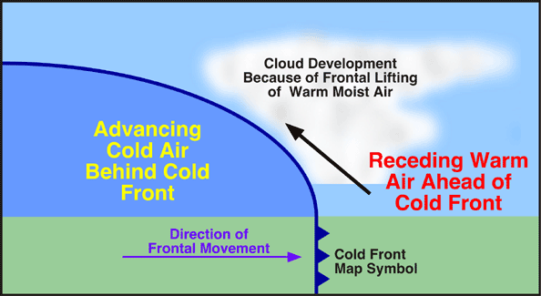
Warm Front | 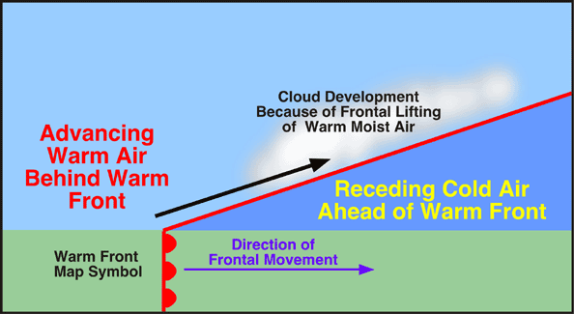
Stationary Front | 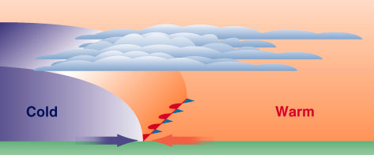

Low Pressure
High Pressure
Air Mass Video: http://www.youtube.com/watch?v=w8oIDvvx8Fk
Watch the demonstration showing the meeting of warm and cold air masses. Why do you think the cold air stayed underneath the warm air mass?
If time permits: Air Mass Quiz: http://www.proprofs.com/quiz-school/story.php?title=fronts-air-masses
Take the quiz and record your results: __________.

- Weather Instruments
Skills Score:

Find illustrations of the following weather tools. Make sure to draw them at the appropriate altitudes in relationship to each other and whether they are over land or water. You may use your layers activity from your notebook and/or the textbook to help you.

radar stations, ground stations, airplanes, ships, satellites, weather balloons, weather buoys

Next to each illustration, write a summary of that device’s function.

Land
Ocean

- Tornadoes
Use the website http://environment.nationalgeographic.com/environment/natural-disasters/
to answer the following about tornadoes.

Once you get to this site, click on “Tornadoes”
Then click on Interactive: Forces of Nature
Step 1: When the number “1” is dark. Read the information about tornadoes in the gray box and answer the following questions. You may have to scroll down to see all of the information.
- What is a tornado?

- Which state has the most twisters per year? How many?

Step 2: Click on the #2. Read the information in the gray box, and answer the following questions.
- What are supercells?

- Where do most tornadoes in America occur?

.

Click on the “next” button to zoom in to see a tornado.
- When do tornadoes form?

- What is an updraft?

Step 3: Click on the #3. Read the information in the gray box, and answer the following questions.

- What type of weather accompanies tornadoes?

Click on “see tornado damage at the bottom of the text.
- How does the Fujita scale measure tornado intensity?

Move around the Fujita scale to see the effects tornadoes of different intensities have.

Click on the #4 to see a video of a tornado passing.

Click on the #5 to answer the following question. You will have to scroll down to answer the question.
- What is the difference between a tornado watch and a tornado warning?

Click on #6 to make a tornado.
1. What conditions are perfect for making a tornado?

Go to http://whyfiles.org/2013/control-a-tornado/ to simulate different types of tornadoes.

- HURRICANES
Skills Score:
Now, you are moving on to “hurricanes.”

http://www.e-missions.net/HurricaneAlert/?cat=72&sid=2&pid=157&page=Introduction

- How are hurricanes formed?

- What conditions must you have in order for a hurricane to form?

- How are hurricanes named?

- What are wind speeds for a category (1) hurricane compared to a category (4) hurricane?

- Write down 5 facts about hurricanes.

- Define:
Category:
Hurricane warning:
Knots:
Tropical storm watch:
landfall:
tropical depression:

- Google typhoons and cyclones.

What do tornadoes, typhoons, and cyclones all have in common?

Explain what makes typhoons, cyclones, and hurricanes all different from each other.

- THUNDERSTORMS
Go to http://www.srh.noaa.gov/jetstream/tstorms/ingredient.htm

- List the 3 ingredients necessary for a thunderstorm.

- What are some of the potential hazards of thunderstorms?

- BLIZZARDS
Day 4 Skills Score:
Go to http://www.ussartf.org/blizzards.htm

- How does the National Weather Service define a blizzard?

- List some of the dangers of blizzards.

- Scroll down to “Keep Ahead of the Storm” What does it mean if each of the following is issued:

Winter Storm Watch Winter Storm Warning.
- Pick a Project Option

Select an option below and let Ms. Taylor know before tracking out. You are not expected to work on this project over track out. You will have time when we return in January.

- Pick a severe weather storm and create a brochure. Your brochure is meant to inform and educate others about the causes, dangers, safety precautions, etc, that are needed for that type of storm. Your final product is a colorful brochure.

- Create a game that asks questions about one type or all four types of storms. What are the causes, dangers, safety precautions, etc? Create a game board, game pieces, questions, and rules. Your final product is the game materials.

- Pick a severe weather event from US history for and research it. What were the causes, damage, lives lost, lasting effects, lessons learned, etc? (i.e. Hurricane Fran, Ohio Valley Tornadoes in April 2011, Snowmageddon in 2008) Create a presentation that demonstrates your learning. Your final product is either a PowerPoint or Prezi.

- Build a model of one of the types of storms. You can make your model out of food, clay, foam, or another material. Your model must show how your type of storm is formed and affects people/property/land; make sure it is labeled. Your final product is a 3-D model.

Rubric for Projects
 | Points Possible | Points Earned
Information used is on topic, factual, and correct. | 20
Information is paraphrased and not ‘copied’ from another source. PUT INFORMATION IN YOUR WORDS! | 10
Project follows all directions given on the Project Options. | 30
Project is neat and well planned, spelling, format, sentence structure of written material is correct. | 10
Relevant pictures/illustrations/diagrams are used to enhance project. | 10
Sufficient information is included to demonstrate learning of that type of severe weather. | 10
Project is completed and turned in by the deadline. | 10
Total | 100

Bill Nye & The Water Cycle | Name:
Student Worksheet  Link: https://vimeo.com/113539794 | Date: | Pd:
Directions: Answer the questions and complete statements from viewing the video.

- How long has water been getting things wet? _____________________________________________________________
- Water can be a _____________ like ice. It can be a _______________ like you drink. It can also be a _________ or vapor.
- Water is always _______________ through something called the water cycle or the _____________logical cycle.
- What happens when water vapor is cooled?
- Circle one: The molecules of boiling water/room temperature water are moving faster.
- How does water at room temperature become a gas?

- What is the “nature” of the water cycle? Water is ___________________.
- Predict: What would happen to a glass of water placed in a closet for a few days?
Why do you think this would happen?
- What is the process of water vapor becoming a liquid?
- Water molecules need a place to “_____________” in order for condensation to happen.
- The energy for our own water cycle on earth comes from the power of the _________.
- Give three examples of precipitation in the rain cycle:

- What is “collection” in the rain cycle?
- No living thing would be able to ___________ without the water cycle
- At the end of the show, Bill Nye says, “If you’ll excuse me, I’ve got some ___________ percolation range to compute”

